The simulation about signal processing in wavenumber and scanning distance domains of white-light interferometers

**I. The first case: φd(σ) = 0 and I(σ) is symmetric.**

Fig.1 shows a white-light scanning interferometer (WLSI) with a white-light source whose spectral intensity is *I*(*σ*), where *σ* is wavenumber. The position of an object surface is *zo*, and the position *z* of a reference surface is scanned by a piezoelectric transducer (PZT). An interference signal is detected with a camera when the PZT is moving. The interference signal has the two components and one of them is constant during the scanning of *z*. Omitting this constant component, the interference signal expressed as a function of the scanning position z is given by

.

Assume  is defined as



where phase *ϕd*(*σ*) is a dispersion phase caused by two sides of unequal length in a cubic beam splitter. Fourier transform of  or the spectral distribution in the region of positive wavenumbers is expressed as



IFT (Inverse Fourier transform) ofis defined as



So, there are two Fourier transform pairs.





where *L*=2(*z*-*zO*) and *L* is the optical path difference.

In addition, assume that  and  form a Fourier transform pair.



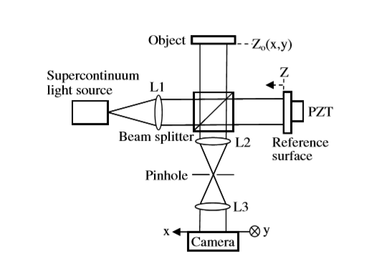

Fig. Schematic of a white-light scanning interferometer.

When the distribution of  is symmetric is evenly symmetric about the origin, *A(2z)=A(-2z)* and .is shown in Fig.2. When  is translated  from the origin to the right, it is equal to that the distribution of *I*(*σ*) is symmetric with a central wavenumber , and .



When ,



In the case of , the distribution of *SC*(*z*) is shown in Fig.3(a) and Fig.3(b).



Fig. The distribution of *I*(*σ’*) and spectral intensity *I*(*σ*)

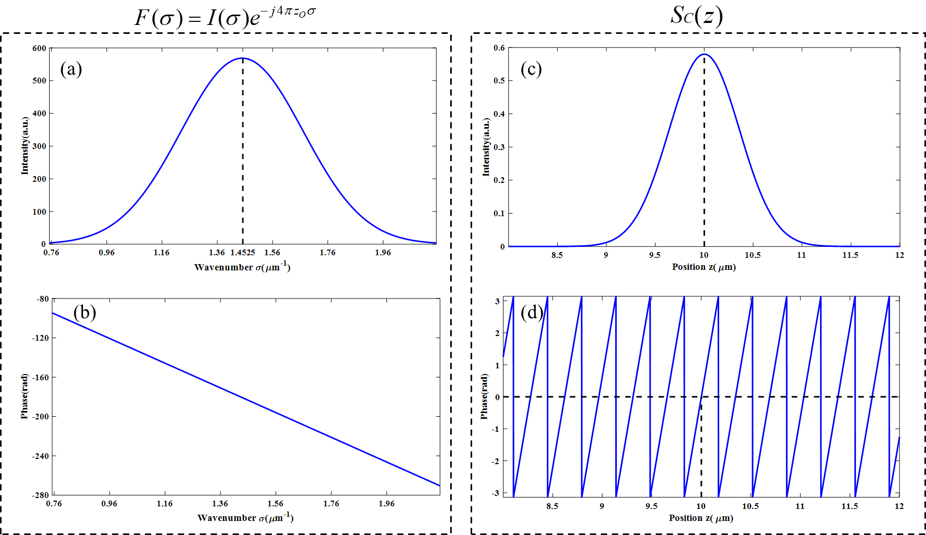

Fig. IFT (Inverse Fourier transform) of *F(σ)*. (a) The intensity of *F(σ)*. (b) The phase of *F(σ)*.

(c) The intensity of *SC(z)*. (d)The phase of *SC(z).*

According to the Eq.(9), the amplitude distribution of *SC*(*z*) is *A(2(z-zO))* and the phase distribution of *SC*(*z*) is . So, the peak position in the amplitude distribution of *SC*(*z*) is *za=zo*, and the zero phase position nearest z=*za* is *zp=zo*. The period of the unwrapped phase distribution is



Fig.3 shows the simulation about the IFT(Inverse Fourier transform) of *F(σ)*. The relevant parameters of *F(σ)* and *SC(z)* are shown in Table 1.

Table . The relevant parameters of *F(σ)* and *SC(z).*

|  |  |  |  |  |  |
| --- | --- | --- | --- | --- | --- |
| σC | zO | λC | za | zp | T |
| 1.4525μm-1 | 10μm | 0.6884μm | 10.0000μm | 10.0000μm | 0.3445μm |

σC: Central wavenumber of *I(σ)*.

zO: The position of an object surface.

λC: Central wavelength of *I(λ)* and *λC = 1/σC.*

za : The peak position in the amplitude distribution of *SC*(*z*).

zp : The zero-phase position in the phase distribution of *SC*(*z*).

T : The period of the unwrapped phase distribution of *SC*(*z*).

**II. The second case: φd(σ) = 0 and I(σ) is asymmetric.**

To simulate the spectral distribution of an actual light source, the distribution of *I*(*σ*) is asymmetric with a weighted average wavenumber *σA*. The distribution of *I(σ)* is shown in Fig.4(a). The weighted average wavenumber *σA* is defined as



In order to obtain a more realistic and asymmetric spectral distribution *I(σ)*, here *I(σ)* is obtained by performing multi-order Gaussian fitting of the actual spectrum. *I(σ)* can be expressed as



IFT of *Gi(σ)* is defined as .



So,





From Euler’s formula we can get the intensity and phase distribution of *SC(z)*,





Where *L=2(z-zO)* and .

Owing to *Si(L) = -Si(L)*, the intensity distribution *A(L)* is evenly symmetric about L= 0 and phase distribution *α(L)* is oddly symmetric about L= 0. According to the Eq.(15), the peak position in the amplitude distribution of *SC*(*z*) is *za=zo*, and the zero phase position nearest z=*za* is *zp=zo*. Similarly, according to the Eq.(10), the period of the unwrapped phase distribution is almost equal to *1/2σA*=*λA*/2.